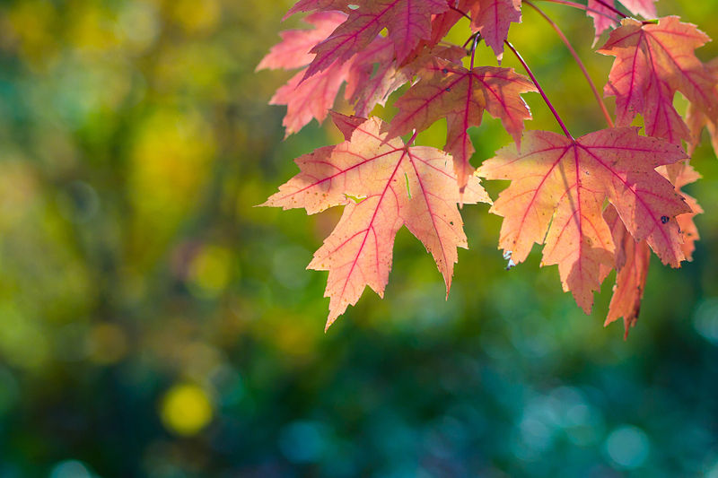
    - EEFHT QUARTERLY
    - FALL 2014
 |  | In This Issue
Flu Season Page 2
Letting Go… Page 2
Fall Recipe Page 3
Programs Page 3

Fall into Healthy Habits

It's getting chilly out there! This time of year is always bittersweet -- we hate saying goodbye to the sunshine, but we love saying hello to warm soups, cuddles by the fireplace and crunchy leaves under our feet.
When the seasons change, it's a great opportunity for us to take a look at where we're at and where we're going. Maybe you feel amazing after weeks of healthy eating, sunshine and playing outside, and you're a teensy bit nervous about carrying those habits into the cooler months.
Fear not. As the weather changes, so should our routines -- your autumn healthy lifestyle may look a bit different than your summer one, but that's to be expected. Staying in tune with the seasons is key to being happy and healthy all year round.
So here are a few tips to keep you healthy this autumn season:
• Eat seasonally. There are so many yummy fruits and vegetables that are in season in the fall, including broccoli, butternut squash, pear, cauliflower, cranberries, key limes, sweet potatoes, and, of course, an essential fall favourite–pumpkin.
• Enjoy outdoor fitness activities. You can still walk, hike, bike, and jog in fall weather. It’ll also give you a chance to enjoy the sights and smells of fall like the brightly coloured leaves, the smell of someone’s fireplace, the cool, crisp evening air…
• Get the flu shot. The flu shot vaccine protects yourself and those around you from getting and spreading the flu.

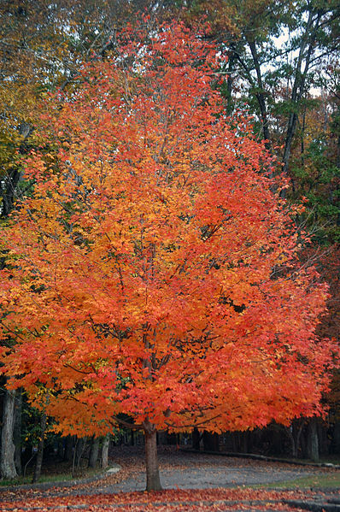

2. You need to get vaccinated every year.
• The effects of the flu vaccine can wear off, so you
need to get a new one every year to stay protected.

• Flu viruses change each year. Experts create a new vaccine to protect you each flu season.

It’s that time of year again…Flu Season

Know the Flu Facts
Influenza (flu) is a contagious respiratory illness caused by influenza viruses. It can cause mild to severe illness. Serious outcomes of flu infection can result in hospitalization or even death. Some people, such as older people, young children, and people with certain health conditions, are at high risk for serious flu complications. The best way to prevent the flu is by getting vaccinated each year.
http://www.cdc.gov/flu/

3. You can’t get the Flu from the flu vaccine.
• The viruses in the flu vaccine are either killed or weakened and cannot give you the flu.

4. The Flu vaccine is safe.
• The flu vaccine has benefited millions of Canadians since 1946.

• Most people don’t have reactions to the flu vaccine; those who do may have soreness, redness or swelling at the injection site.

• Severe reactions to the vaccine are extremely rare.

1. The Flu can be a serious disease.
• Flu is very contagious and can spread quickly and easily.

• You can pass the flu on to others who may be at risk of
serious complications, before you even know you are sick.

• The flu is responsible for about 12,200 hospitalizations and
3,500 deaths per year1 and can affect everyone, including
those who are healthy.

http://www.healthycanadians.gc.ca/alt/pdf/diseases-conditions-maladies-affections/disease-maladie/flu-grippe/facts-faits-eng.pdf
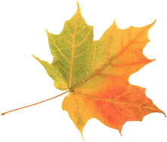
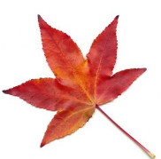

Letting go…

“Surrender to what is. Let go of what was. Have faith in what will be.” – Sonia Ricotti.

Autumn is the end of the growing season. Leaves fall from the trees and return to the earth, enriching the soil for next year’s growing season. Just as leaves fall from the trees, autumn is a good time to let go of the things that no longer serve us, so our lives may be more enriched. As humans, letting go is difficult. We hold on to our favourite material objects even though they become broken or worn out over time. We cling to relationships we know are toxic, even though we know this will only bring suffering. We need to learn to let go. Let go of negativity, let go of the need to always be right, let go of toxic friendships, let go of anything that does not feel good.
Letting go of unwanted things, habits, attitudes beliefs and people is an ongoing process. As you practice letting go, you begin to break the strong identification you have with the emotions that arise within you from moment to moment. This allows you to feel more peace and joy, even when things don't go your way. As you continue to let go, you will begin to feel lighter, happier, more at ease — both within your own skin and in the world.

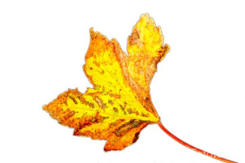
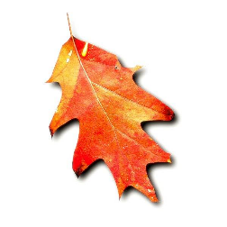
This is a delicious vegetarian recipe. This dish combines the earthy flavors of mushrooms and squash with the sweetness of maple for an impressive dinner or appetizer that is sure to please any crowd!

Ingredients
- 1-2 cups favorite mushrooms, sautéed
- 1/2 cup onions, caramelized
- Squash, sliced
- 1 handful of your favorite greens (such as spinach or chard)
- 1 Tbsp pure maple syrup
- 1 tsp olive oil + extra to brush on crust
- Naan bread
- Parmesan cheese, grated
- Salt and pepper to taste

Instructions
- Preheat oven to 350 degrees.
- Drizzle the naan bread lightly with olive oil, and brush to coat.
- Top with onions and greens.
- Toss mushrooms and squash in maple syrup and olive oil, then sprinkle on top
of greens and onions.
- Top with Parmesan if desired, and bake on baking sheet for 15 minutes, or until crust is golden brown and squash is tender.

Sidebar Setup
The sidebars in this template use simple, single-row tables for the gray-shaded headings and thermometer charts shown below for easy alignment.

Add Sidebar Content
Source: http://www.purecanadamaple.com/maple-syrup-recipe/maple-mushroom-pizza

Programs
by [Article Author]
CHANGES AND CHOICES SUPPORT GROUP: this program is for EEFHT patients who want to implement any type of healthy lifestyle change such as healthy eating, physical activity, and/or stress management. The program is led by Lee Ann Boucher, RSW and Donna Reid, Health Promoter bi-weekly on Thursday evenings. The program runs on a drop in basis meaning that patients do not have to commit to every session and can join at any time!

For More Information
Contact Donna for more information about the program at 705-235-6904

We look forward to hearing from you!



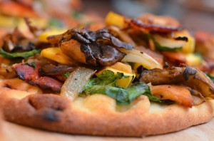

Maple Mushroom Pizza
by Jennifer Moran

